**SECTION 9**

**SCREENSHOTS**

**Student output :**

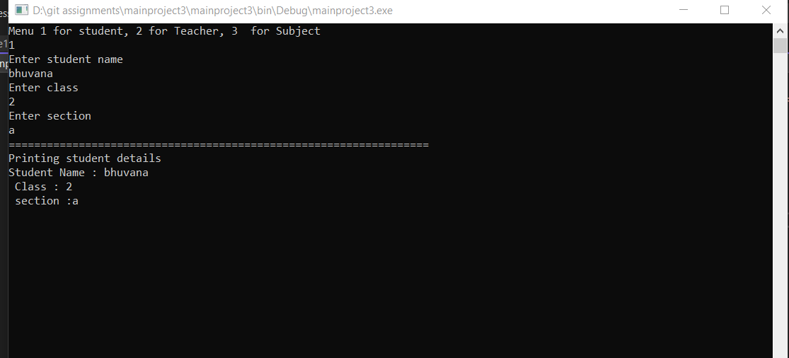

**Teacher output:**

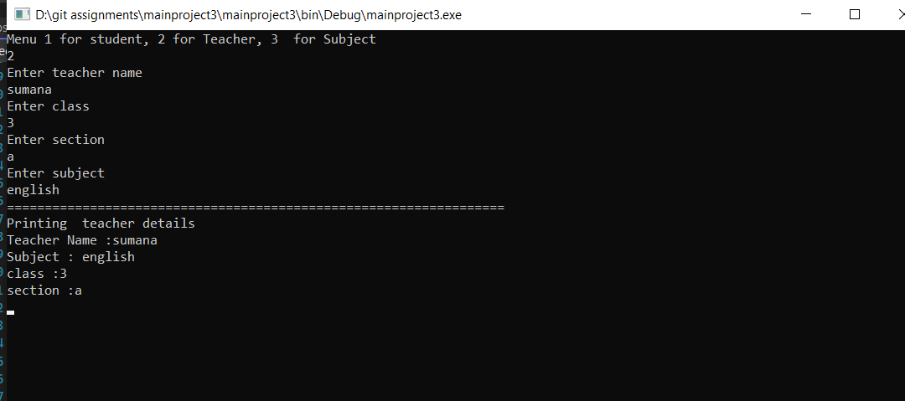

**Subject output:**

